BUSINESS QUESTIONS BEING ANSWERED IN MYSQL

Q1. What is the total revenue generated by male vs. female customers?
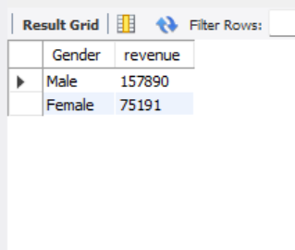
MYSQL was used to compare revenue generated by male vs female and this was the outcome.

Q2. Which customers used a discount but still spent more than the average purchase amount?

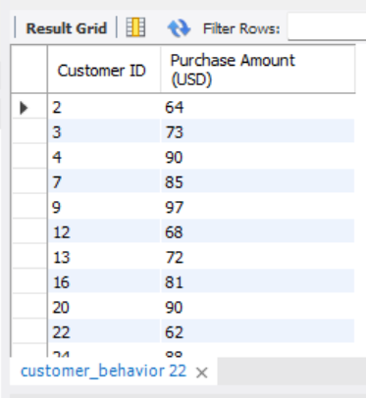
The results above highlighted customers who used a discount bill but still spent more than the average purchase amount.

Q3. Which are the top 5 products with the highest average review rating?

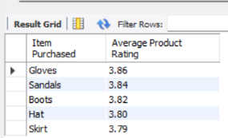
Found products with the highest average review ratings.

Q4. Compare the average Purchase Amounts between Standard and Express Shipping.

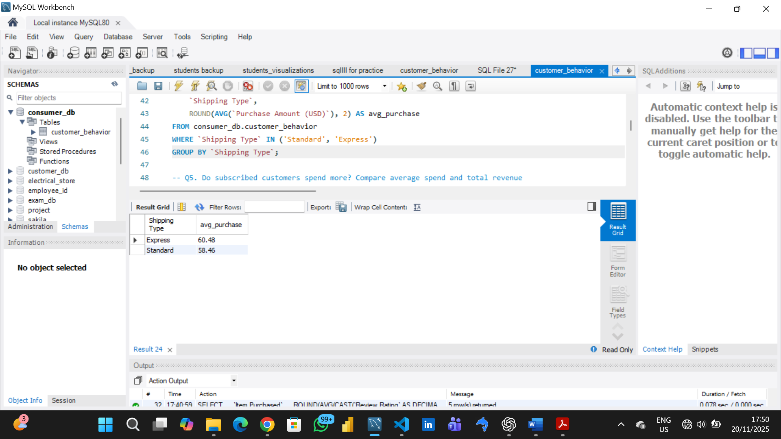
Compared average purchase amounts between Standard and Express shipping.
Q5. Do subscribed customers spend more? Compare average spend and total revenue
between subscribers and non-subscribers.

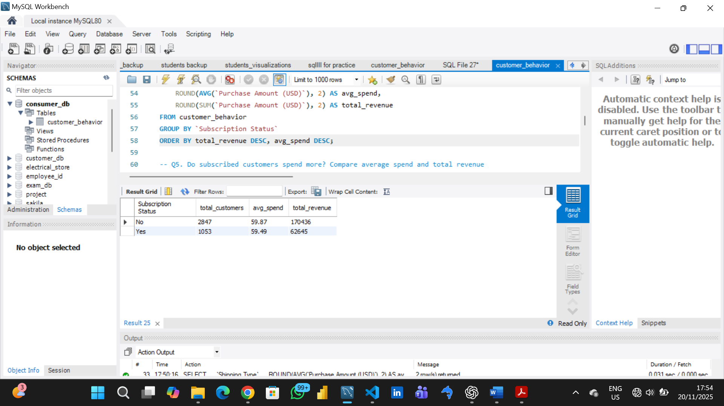
Compared average spend and total revenue across subscription status.

Q6. Which 5 products have the highest percentage of purchases with discounts applied?

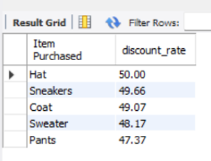

Identified 5 products with the highest percentage of discounted purchases.

Q7. Segment customers into New, Returning, and Loyal based on their total
number of previous purchases, and show the count of each segment.

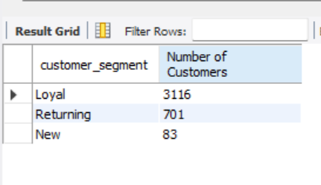
Classified customers into New, Returning, and Loyal segments based on purchase history .

Q8. What are the top 3 most purchased products within each category?

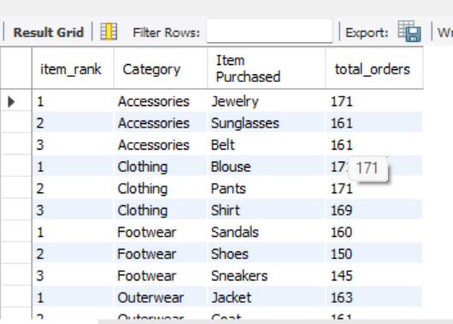

Listed the most purchased products within each category.
Q9. Are customers who are repeat buyers (more than 5 previous purchases) also likely to subscribe?

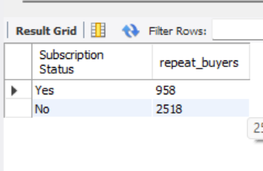

Checked whether customers with >5 purchases are more likely to subscribe.
Q10. What is the revenue contribution of each age group?
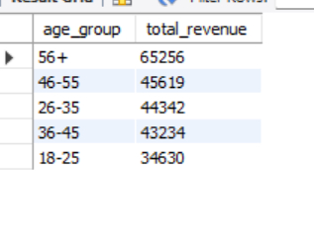
Calculated total revenue contribution of each age group.

